CitySafe: Urban Disaster
Response App

A Capstone Project
Presented to the Faculty of the
College of Information Technology Education
PHINMA University of Iloilo

In Partial Fulfillment
of the Requirements for the degree
Bachelor of Science in Information Technology

By:
Jabao, Mark Vincent
Tabalina, Jayrold
Talaman, Yasmine

October 2025

Table of Contents
Chapter I 3
Introduction to the Study 3
Technical Background of the Study 4
Statement of the Problem 5
Objectives of the Study 6
Significance of the Study 6
Scope and Limitations of the Study 7
Definition of Terms 8
Chapter II 9
Review of Related Literature 9
References 10
Chapter III 10
Methodology 11
Research and Development Stage 11
Software Development Life Cycle (SDLC) 12
Key Features of Agile: 12
Phases of Agile we used in CitySafe: 13
Data Collection Techniques 14
Justification for Using the Agile Model 14
System Architecture and Design 15
3.1 Overview 15
3.2 System Architecture 15
3.3 System Components and Modules 16
Use Case Diagram 17
Data Flow Diagram (DFD) 18
Entity Relationship Diagram (ERD) 20
3.4 Database Design 21
Entity Relationships Summary 24
3.5 User Interface Design 25
3.6 Security Considerations 28
3.7 Technology Stack 28
Data Gathering Techniques 28
Survey Questionnaire for System Assessment 28
Sampling Methods for Respondents 32
5. Data Analysis Techniques 32
1. Statistical Methods for Processing Data 32
Interpretation of Weighted Mean 33
2. Framework for Evaluating System Effectiveness 34
6. Ethical Considerations 35
Chapter IV 35
Results and Interpretation 35
Summary of the data sources and analysis methods used 35
3.1 Presentation of Results 37
Impact on the Information Technology Field 48
Contribution to Technological Advancements 48
Code impression Management 48
System/app Screen shots 52
Features of the System/App 55
System Repository 56
Project Structure 56
Chapter v 58
Summary, Conclusion, And Recommendation 58
References (APA Format) 60

Chapter I

Introduction to the Study
The goal of this capstone project is to create a web application where people can monitor disasters, track disaster victims, send their help, and send reliefs to the people affected by the disaster within their city. This study aims to improve disaster response by creating a web application that focuses mainly for tracking disasters, a centralized platform for asking and sending resources to the victims. It minimizes clutter and distractions unlike other famous social media apps; this web application will focus mainly on tracking disasters and the victims, allocating and managing resources from the donor to the victims in a community.
The project focuses on creating a web application with user-friendly interface that allows users to easily navigate their way through the app, therefore increasing efficiency and saves a lot of time familiarizing on how the app works. It is helpful for affected citizens and disaster response teams and donors to manage relief aids and allocate it properly.
By the end of this project, the system will help the city response team track disaster victims, monitor possible disaster, and manage donations like foods and clothing. This will also increase their efficiency and reaction time on providing help to the victims.

Technical Background of the Study
Disasters like typhoons, earthquakes, and floods are one of the challenges that the communities face especially our country is within the Pacific Ring of Fire (Raba, 2025). Communication becomes harder, and coordination between citizens, emergency responders, and city officials usually is not efficient. These makes the disaster response and help becomes delayed, not enough aid or relief distribution, and it adds to the suffering of the affected individuals. Today modern technology, particularly web applications, has the potential to connect these gaps by providing real-time communication and coordination tools.
CitySafe is designed to be an urban disaster response web application. It aims to connect citizens, emergency responders, and city officials during disasters. The app will allow donors to see what the victims need and provide goods directly to victims in need, thus creating a more efficient way of giving aid or help. With CitySafe, we hope that the urban communities can respond to disasters more effectively and compassionately.

Statement of the Problem
The disasters give several issues in urban response systems, like:
- Lack of real-time communication between affected citizens and emergency responders.
- Slow coordination among city officials, and responders.
- Difficult to track and provide assistance to disaster victims.
- Poor allocation of man-force makes it hard for the responders to assist the affected citizens.
The problems encountered will caused a delayed rescue effort, unequal distribution of aid, and adds to the suffering of the victims. This study aims to address these challenges by proposing a solution by creating a web-app CitySafe.

Objectives of the Study
The main objective of this study is to develop a web application that improves disaster response in urban areas. Specifically, the study aims to:
- Create a tracking platform connecting citizens, responders, and donors/benefactors.
- Help improve coordination time during disasters.
- Create an easy-to-use web-app for users with faster learning curve.

Significance of the Study
This study is significant for the following stakeholders:
- Citizens: CitySafe will help them broadcast their emergencies on a single platform during disasters and receive assistance.
- Emergency Responders: The app will assist in finding and locating people in need and helps track what disasters to come.
- City Officials: It will provide tools for better management and resource allocation during disasters.
- Future Researchers: This study can help as a reference for future innovations in disaster response technology.
By addressing these things in current disaster response systems, this app aims to save lives and reduce suffering during urban disasters and soon expand to rural areas.

Scope and Limitations of the Study
Scope:
- The app will focus on urban areas where disaster response coordination is a challenge and with internet coverage.
- It will provide features such as real-time communication, donation management, and updates during disasters.
- The app will support multiple stakeholders, including citizens, emergency responders, and donors.
Limitations:
- The app depends on internet connectivity, which may be disrupted during severe disasters.
- Initial deployment will be limited to a few urban areas for testing and improvement.
By understanding the scope and limitations, this study aims to set a realistic expectations and goals while helping contributing to the development of disaster response technology. Future research can use this study and improve the system.

Definition of Terms
- CitySafe: A web application designed to connect citizens, emergency responders, benefactors, and donors during urban disasters.
- Web Application: it is an interactive software program, is an application accessible through the web using a web browser, it needs internet connection.
- Internet: The internet is a global network that connects devices and users.
- Disaster: An event such as a typhoon, earthquake, fire or flood that causes significant damage to urban communities.
- Emergency Responders: Individuals or teams who are for who providing immediate assistance during disasters, like paramedics, firefighters, and rescue personnel.
- Urban Areas: Regions known by high population density and developed infrastructure, where the app will be deployed.
- Aid Distribution: The process of delivering support or assistance to disaster victims in need.
- Resource Allocation: The management and assignment of available resources, such as personnel, goods, or funds, to areas requiring support during disasters.
- Internet Connectivity: Access to the internet, required for the app to function.

Chapter II

Review of Related Literature
Disaster in the Philippines and around south east Asia is very common. Given that the Philippines lies in the Pacific Ring of Fire makes it vulnerable to numerous disastrous events and calamities (Escolano et al., 2023). According to Domingo and Manejar (2018), the Philippines is prone to natural disasters as it lies along both the typhoon belt and the Pacific ring of fire. This leads us to develop an app and utilize modern means to solve modern problems. Chapelle (2004) says, “Modern problems require modern solutions.”
Most people now, if not all, have smartphones and other gadgets that keep them updated about what is happening around them. Data on disasters are becoming widely available to support technology development (Escolano et al., 2023). It is really evident now how technology can help us during disasters. Also, according to Escolano et al. (2023) smartphones revolutionize disaster communication as they are used as tools to streamline information during disasters. Another common example of how technology is used is the SMS notifications sent by NDRRMC during disasters and similar events. The application of technology in respond to disasters is really useful especially nowadays most of us have phones and other gadgets.
According to a study Disaster Preparedness and Local Governance in the Philippines, in a disaster-prone country like the Philippines, much is expected from the local governments which are considered to be the core of a community (Domingo & Manejar, 2008). It is really important that local government initiates the need to help those in their area and constituents. Technology can greatly improve these coordination’s between the community and local government. Moreover, according to an article on publichealth.tulane.edu says, “Mobile applications have been a key part of technology in disaster emergency management and preparedness” (Technology in Disaster Management and Recovery: Types and Impact, 2024). Thus, technology can greatly help victims, and improve response time of the city officials/government.

References
Domingo, S., & Manejar, A. J. (2018). Disaster Preparedness and Local Governance in the Philippines. Philippine Institute for Development Studies.
Escolano, V. J., Caballero, A. R., Albina, E., Hernandez, A., & Juanatas, R. (2023, May). Acceptance of Mobile Application on Disaster Preparedness: Towards Decision Intelligence in Disaster Management. ResearchGate.
Technology in Disaster Management and Recovery: Types and Impact. (2024, April 14). Tulane University.
Raba, W. J. (2025, August 12). Pacific Ring of Fire: Tracing natural disasters in Southeast Asia. Seasia: Good News from Southeast Asia. https://seasia.co/2025/08/12/pacific-ring-of-fire-tracing-natural-disasters-in-southeast-asia

Chapter III

Methodology
This chapter outline the research methods used in developing the CitySafe: Urban Disaster Response App. The main goal of this study is to design and build a web-based system that helps connect citizens, donors, city officials, and emergency responders during disasters.
This chapter describes the research process, data gathering methods, system design, tools, and techniques used to achieve the goals of the project. The researchers followed a systematic process to ensure the proper and effective development of the app.
At the beginning, the researchers studied existing disaster response systems, related websites, and articles to find problems and possible improvements. After gathering this information, the system design and development process was done step by step.
To understand the needs and expectations of the users, the researchers conducted surveys and collected feedback from different respondents such as citizens, local officials, and volunteers. Their responses helped guide the design and functionality of the CitySafe app to make sure it fits real-life disaster response situations.
After development, the system was tested to check its performance, usability, and reliability. This chapter presents all the research processes that guided the development to make sure the project was done in an organized and effective way.

Research and Development Stage
The Research and Development (R&D) stage played an important role in creating the CitySafe App. During this stage, the development process is guided by the feedbacks that we gathered from the respondents. The opinion and feedbacks from the respondents helped us design the features that were useful and practical in creating the app for disasters and emergencies.
The R&D stage began with analyzing the data collected from surveys and feedback. The results helped identify problems that people face during disasters such as lack of communication, delayed rescue response, and poor coordination between agencies.
Based on the analysis, the design of CitySafe included important features like real-time disaster reporting, donation tracking, and map-based location of stations and shelters using Leaflet.js. The feedback also helped improve the user interface and ensure that it was easy to use.
The app was developed in stages. After every stage, the researchers conducted testing to make sure that all features were working correctly. Additional feedback was gathered after each test to make further improvements. Once the prototype was ready, real users were allowed to test it to ensure it was functional, user-friendly, and reliable.

Software Development Life Cycle (SDLC)
The Agile Software Development Life Cycle (SDLC) model was used for developing the CitySafe App. Agile was chosen because it allows continuous testing, improvement, and feedback, which are very important for building the system that meets users’ needs.

Key Features of Agile:
- Iterative Development: The system was built in small parts (called sprints) so improvements could be added easily.
- Continuous Feedback: Regular comments from users and team members helped improve the system.
- Collaboration: Developers, users, and project advisors worked closely together.
- Flexibility: Changes were accepted even in later stages of development.

Phases of Agile we used in CitySafe:
- Planning and Requirement Analysis:
The researchers identified the purpose of CitySafe and gathered the requirements from respondents. They planned the system’s features such as user registration, disaster reporting, donation management, and location mapping.
- System Design:
The researchers designed the structure, layout, and flow of the app. They used wireframes and diagrams to plan how each page and function would look.
- Development:
The actual coding was done using Node.js, Express, EJS, and MySQL for the backend, while Leaflet.js was used for the map features.
- Testing:
The app was tested for bugs and errors. The team checked whether all functions like reporting, login, and map updates were working correctly.
- Deployment:
After successful testing, the app was launched for actual users to try. Feedback from these users helped find areas for improvement.
- Maintenance and Support:
The system was updated based on user feedback. Fixes and improvements were made to make sure CitySafe continues to work smoothly and securely.

Data Collection Techniques
The researchers used different data collection methods to gather information that helped in developing the CitySafe App.
- Surveys
Surveys were used to gather information from citizens, local officials, and volunteers. The questions focused on their experience during disasters, communication challenges, and what kind of features they expected from a disaster response system.
- Observation
The researchers observed real situations during disaster drills and community activities. This helped them understand how communication and coordination are handled in emergencies.
- Document Analysis
Existing disaster management websites, government manuals, and case studies were analyzed to understand how other systems worked. This helped the team identify what features were missing and what could be improved in CitySafe.

Justification for Using the Agile Model
Criteria | Agile Methodology | Waterfall Model
Flexibility | High – changes can be made anytime | Low – hard to change after design
User Involvement | Continuous feedback from users | Only at start and end
Development Speed | Faster because of small sprints | Slow, step-by-step process
Risk Management | Problems are found early | Risks are found late
Best Use Case | Useful for evolving systems | Works for fixed requirements
Agile was chosen because CitySafe needed constant updates and improvements based on user feedback. It also allowed faster development and easier modification when new ideas came up.

System Architecture and Design

3.1 Overview
The CitySafe App is a web-based system designed to connect citizens, responders, and donors during disasters. It helps users report emergencies, view safe zones, and track donation activities in real time.

3.2 System Architecture
The system is divided into three main layers:
- Presentation Layer: Web interfaces for users and admin.
- Application Layer: Handles user requests, report processing, and notification logic.
- Data Layer: Stores data such as user accounts, reports, donations, and risk assessments in the database.
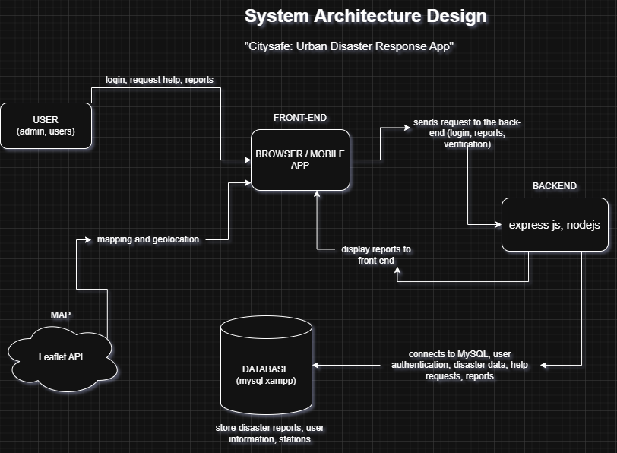Figure 1: System Architecture Design

3.3 System Components and Modules
3.3.1 User Management Module – Handles registration, login, and role permissions.
3.3.2 Disaster Reporting Module – Allows citizens to report disasters with photos and locations.
3.3.3 Donation Management Module – Lets donors send help and track their donations.
3.3.4 Risk Assessment Module – Helps users submit safety and risk assessments.
3.3.5 Station Locator Module – Using Leaflet.js to display the emergency stations on the map.
3.3.6 Notification Module – Sends alerts about ongoing disasters or important updates.

Use Case Diagram
The Use Case Diagram is showing how each of the users interacts with the system and what actions they can perform.
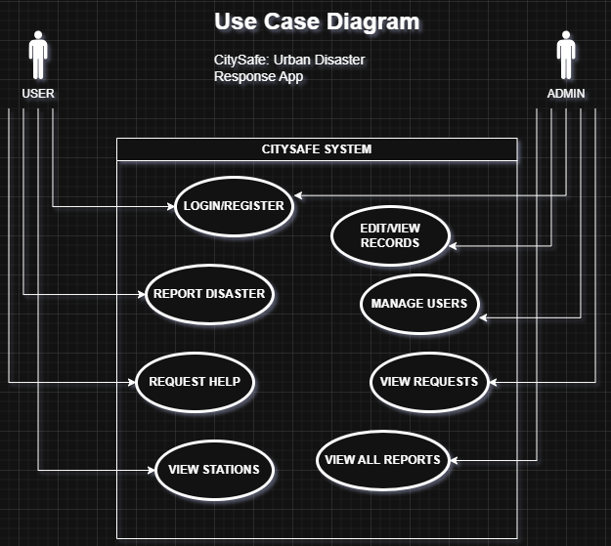Figure 2: Use Case Diagram

Data Flow Diagram (DFD)
The DFD shows how data moves inside CitySafe - from when a user reports a disaster to how it is processed by the system, and stored in the database.
Level 0 (Context Diagram):
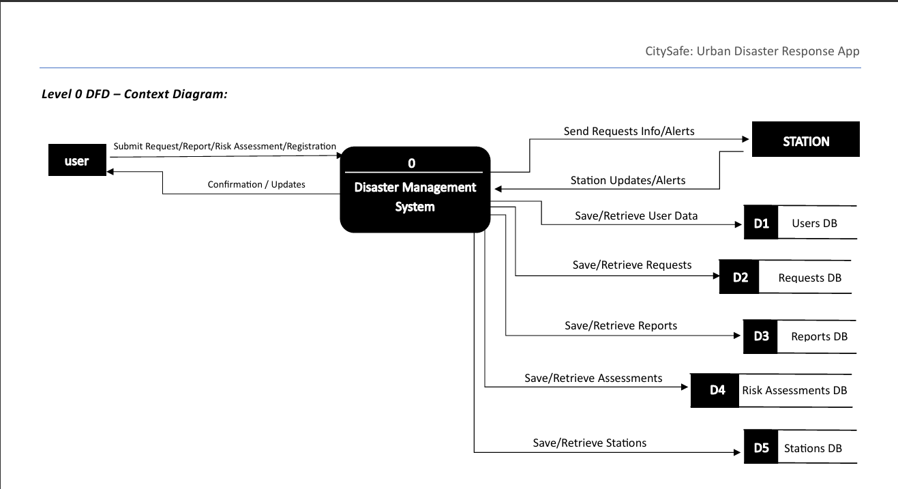
Figure a. Level 0 (Context Diagram)
The figure above shows the main system as a single process that interacts with the users and database.

Level 1 (Main Process):
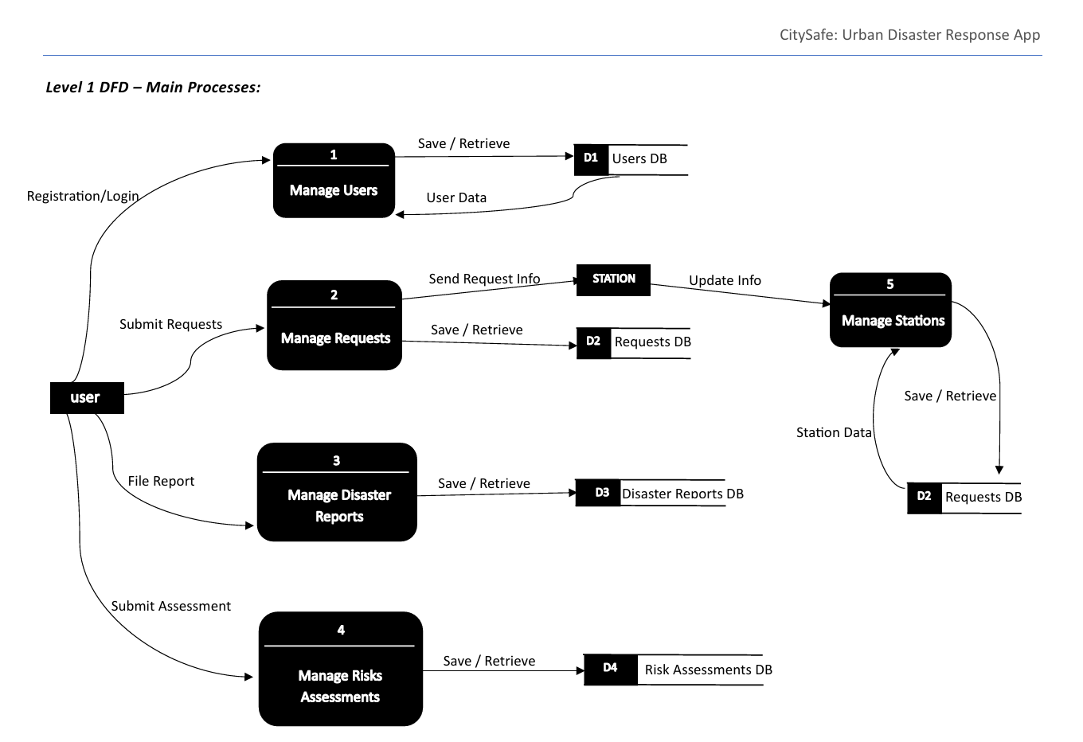
Figure b. Level 1 (Main Process)
This figure breaks down the processes like the user login, reports submission, and data retrieval.

Entity Relationship Diagram (ERD)
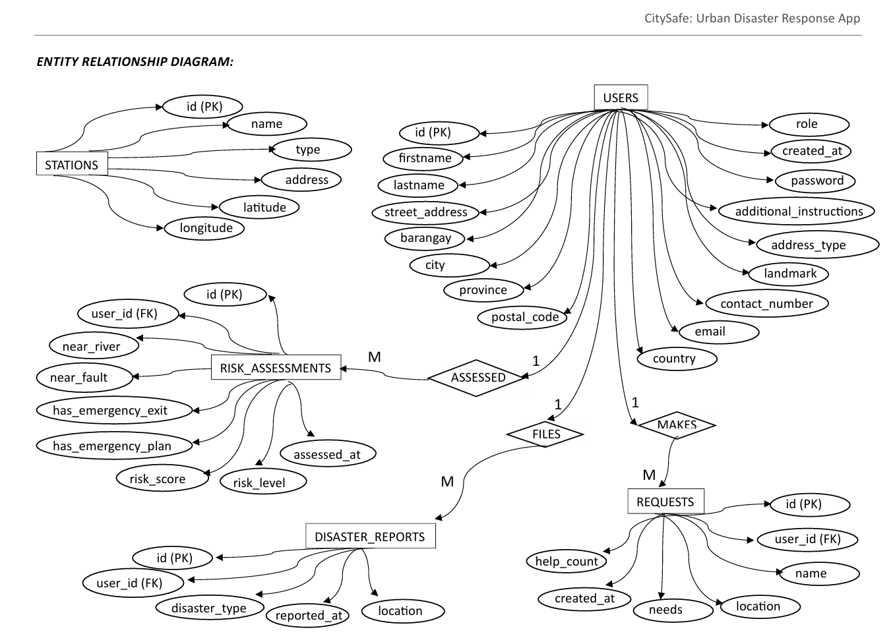Figure c. Entity Relationship Diagram
The ERD defines the relationship between the main entities:
- A User can make many Requests - (1-M)
- A User (Donor) can make many Donations - (1-M)
- A Donation may be linked to one Request - (M-1)
- A User can submit many Risk Assessments - (1-M)
- A User can file many Disaster Reports - (1-M)
- Admins are special Users with management privileges - (1-1)
- Stations exist independently and we mapped via Leaflet (it is location-based, not linked to Foreign Key).

3.4 Database Design
1. Database Structure Overview
The CitySafe database is designed to store and manage disaster-related information, user data, and risk assessments efficiently. It contains of five main tables:
users, disaster_reports, requests, risk_assessments, and stations.
Each table has a specific role:
- users contain information about the admin and regular users.
- disaster_reports records all reported disaster events by the users.
- requests stores help or resource requests made by the affected users.
- risk_assessments this stores the evaluation of each user’s level of disaster risk based on their location and preparedness.
- stations store data about police and fire stations near affected areas.
Relationships are being managed through Foreign Keys connecting the tables, by mainly connecting them to the users table to track ownership or responsibility.

2. Entity-Relationship Diagram (ERD)

Relationship summary of the figure above:
- One user can submit many disaster_reports.
- One user can create many requests.
- One user can have one or more risk_assessments.
- stations are independent reference entities (we didn’t link using foreign keys, but used for mapping & reporting).

3. Description of Main Entities
Users
- Purpose: Stores personal and contact details of registered users.
- Primary Key: id
- Important Fields:
- firstname, lastname – User’s full name.
- email, contact_number – Used for login or identification.
- role – Defines whether the user is an admin or user.
- created_at – Timestamp when the user registered.
Disaster_Reports
- Purpose: Records all disaster incidents reported by users.
- Primary Key: id
- Foreign Key: user_id - references users(id)
- Important Fields:
  - disaster_type – Type of disaster (e.g., Fire, Flood, Earthquake).
  - reported_at – Time the report was submitted.
  - location – Address or coordinates of the disaster event.
Requests
- Purpose: Stores user requests for assistance or supplies during disasters.
- Primary Key: id
- Foreign Key: user_id - references users(id)
- Important Fields:
  - name – Name of the person requesting help.
  - location – Address where help is needed.
  - needs – Details about what resources are required (food, clothing).
  - help_count – Number of times help has been provided.
  - created_at – Time when the request was made.
Risk_Assessments
- Purpose: Records disaster risk evaluations for each user based on their environment and preparedness.
- Primary Key: id
- Foreign Key: user_id - references users(id)
- Important Fields:
  - near_river, near_fault – Boolean values indicating environmental risks.
  - has_emergency_kit, has_evacuation_plan – Preparedness indicators.
  - risk_score, risk_level – risk rating (Low, Moderate, or High).
Stations
- Purpose: Contains data about nearby police and fire stations that can respond to disaster incidents.
- Primary Key: id
- Important Fields:
  - name – Station name.
  - type – for now we have PNP or BFP stations.
  - address, latitude, longitude – used for tracking location.

Entity Relationships Summary
Relationship | Type | Description
Users-Disaster_Reports | One-to-Many | A user can report many disaster incidents.
Users- Requests | One-to-Many | A user can make many requests for help.
Users- Risk_Assessments | One-to-Many | Each user can take one or more risk assessments.
Stations | Independent | Contains fixed data for mapping responders.

3.5 User Interface Design
The user interface is designed to be simple, clean, and responsive. It allows users to easily submit disaster reports, check safety locations, and manage donations.
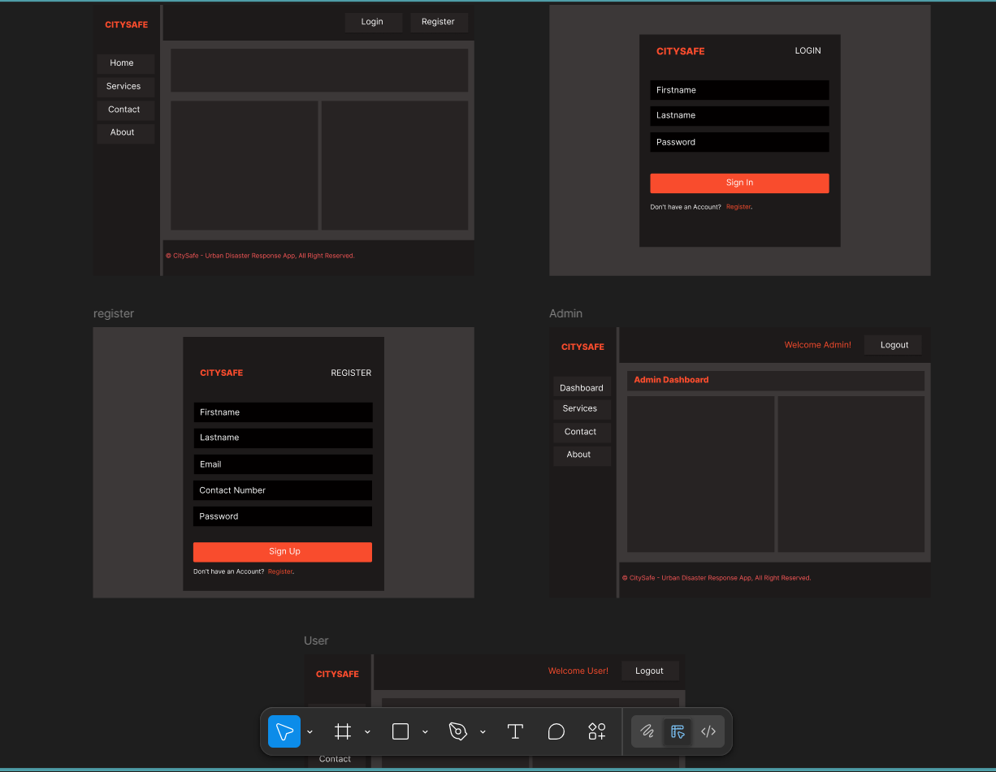Figure 1: CitySafe wireframe

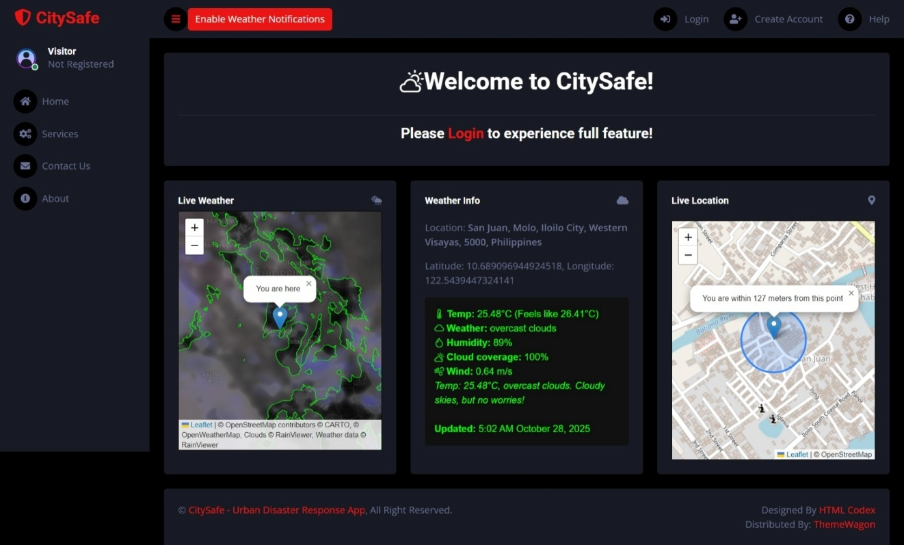Figure 2: Citysafe user-interface
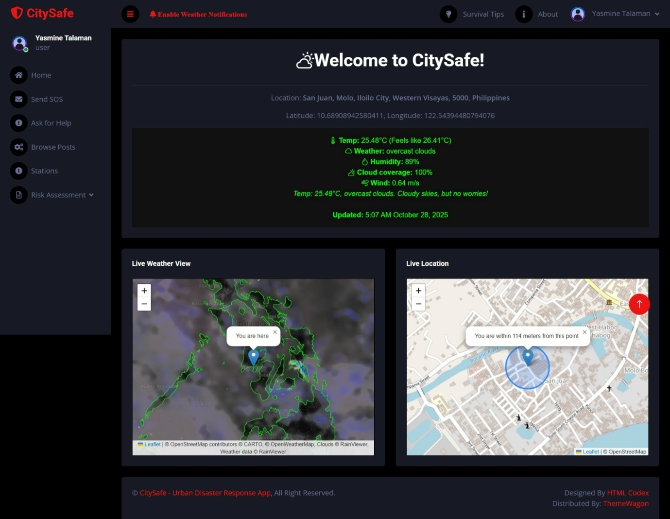Figure 3: Citysafe user dashboard
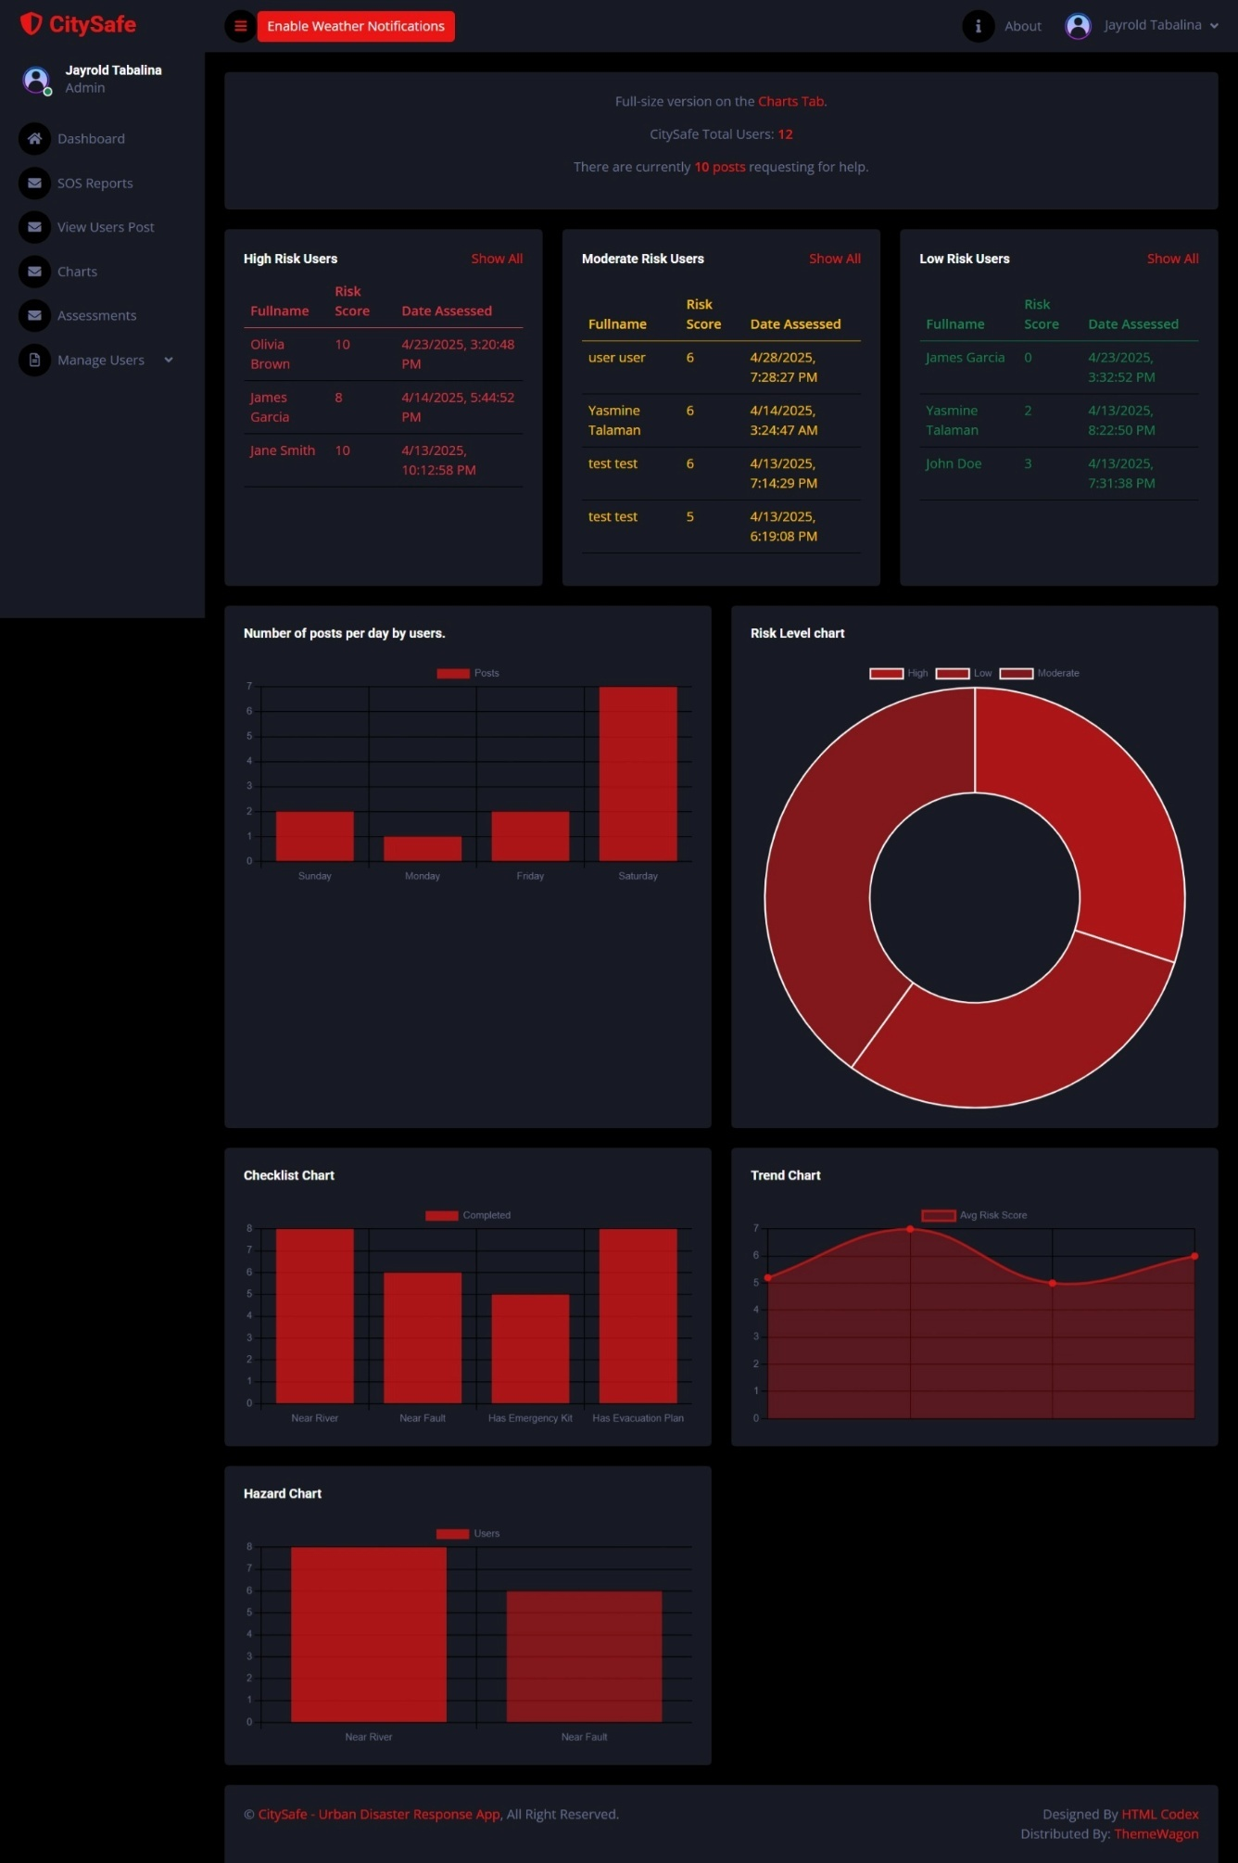
Figure 4: Citysafe Admin dashboard

3.6 Security Considerations
- Login authentication for users and admin.
- Role-based access (citizens, admins).
- Encrypted database connections for secure data transmission.
- Protection of user information and reports.

3.7 Technology Stack
- Frontend: HTML, CSS, Bootstrap 5, EJS
- Backend: Node.js, Express
- Database: MySQL XAMPP
- Map: Leaflet.js
- Charts: Google charts
- Server Environment: Localhost for testing, that is ready for cloud deployment (we use Railway.com when deploying)

Data Gathering Techniques

Survey Questionnaire for System Assessment
This questionnaire aims to gather feedback from respondents after testing or observing the CitySafe prototype. The purpose is to evaluate the performance, usability, helpfulness, and overall satisfaction with the system to support the research and further improvement of the project.
Likert scale:
Scale | Description
5 | Strongly Agree
4 | Agree
3 | Neutral
2 | Disagree
1 | Strongly Disagree

A. System Performance
No. | Statement | 5 | 4 | 3 | 2 | 1
1 | The CitySafe system installs or loads correctly. | ☐ | ☐ | ☐ | ☐ | ☐
2 | The CitySafe interface works properly on the device. | ☐ | ☐ | ☐ | ☐ | ☐
3 | The CitySafe features can be accessed without errors. | ☐ | ☐ | ☐ | ☐ | ☐
4 | The CitySafe system loads fast during testing. | ☐ | ☐ | ☐ | ☐ | ☐
5 | The system responds properly when performing actions. | ☐ | ☐ | ☐ | ☐ | ☐
6 | The system works without noticeable errors or crashes. | ☐ | ☐ | ☐ | ☐ | ☐
7 | The system performs well according to its intended functions. | ☐ | ☐ | ☐ | ☐ | ☐

B. System Usability
No. | Statement | 5 | 4 | 3 | 2 | 1
8 | The system is easy to use and understand. | ☐ | ☐ | ☐ | ☐ | ☐
9 | The buttons and menus are well-organized and visible. | ☐ | ☐ | ☐ | ☐ | ☐
10 | The design and layout are clear and user-friendly. | ☐ | ☐ | ☐ | ☐ | ☐
11 | I can easily find the features I need. | ☐ | ☐ | ☐ | ☐ | ☐
12 | The system is simple enough for first-time users to navigate. | ☐ | ☐ | ☐ | ☐ | ☐

C. System Helpfulness and Effectiveness
No. | Statement | 5 | 4 | 3 | 2 | 1
13 | The CitySafe system can help improve disaster communication and response. | ☐ | ☐ | ☐ | ☐ | ☐
14 | The map and location feature are helpful for finding safe areas and responders. | ☐ | ☐ | ☐ | ☐ | ☐
15 | The reporting and donation tracking features can support coordination during disasters. | ☐ | ☐ | ☐ | ☐ | ☐
16 | The system can help citizens feel more secure and informed. | ☐ | ☐ | ☐ | ☐ | ☐
17 | The CitySafe system has potential to be useful in real disaster situations. | ☐ | ☐ | ☐ | ☐ | ☐

D. User Satisfaction
No. | Statement | 5 | 4 | 3 | 2 | 1
18 | Overall, I am satisfied with the design and features of the CitySafe system. | ☐ | ☐ | ☐ | ☐ | ☐
19 | The system meets my expectations as a disaster response platform. | ☐ | ☐ | ☐ | ☐ | ☐
20 | I believe the system should be developed further and officially implemented. | ☐ | ☐ | ☐ | ☐ | ☐

Sampling Methods for Respondents
The respondents for this survey will be selected using Purposive Sampling, only respondents who tested or viewed the system prototype are selected.
Sample Size: Minimum of 20 respondents.
Data Analysis: The survey results are interpreted using the Likert Scale:
Range | Interpretation
4.21–5.00 | Very Satisfactory
3.41–4.20 | Satisfactory
2.61–3.40 | Neutral
1.81–2.60 | Unsatisfactory
1.00–1.80 | Poor

5. Data Analysis Techniques

1. Statistical Methods for Processing Data
The data gathered from the survey questionnaire were tabulated, organized, and analyzed using descriptive statistics.
Each item in the questionnaire used a five-point Likert scale, where:
Scale | Description
5 | Strongly Agree
4 | Agree
3 | Neutral
2 | Disagree
1 | Strongly Disagree
The following statistical tools were applied:
- Frequency and Percentage Distribution
Used to summarize the number and percentage of respondents for each scale per question.
- Weighted Mean
Computed to determine the average perception of respondents for each category (System Performance, Usability, Helpfulness, and Satisfaction).
The formula used:
$$\text{Weighted Mean (WM)}\text{=}\frac{∑(f×x)}{N}$$
Where:
𝑓
f = frequency of responses
𝑥
x = weight of the response
𝑁
N = total number of respondents

Interpretation of Weighted Mean
Weighted Mean Range | Verbal Interpretation
4.21 – 5.00 | Very Satisfactory
3.41 – 4.20 | Satisfactory
2.61 – 3.40 | Neutral
1.81 – 2.60 | Poor
1.00 – 1.80 | Very Poor
The results were analyzed per category and overall to determine the general performance and usability of the CitySafe system based on user feedback.

2. Framework for Evaluating System Effectiveness
To assess the overall effectiveness of CitySafe, the study adapted the ISO 9126 Software Quality Model as an evaluation framework, focusing on the following key attributes:
ISO 9126 Attribute | Description | Related Survey Category
Functionality | The degree to which the system performs its intended functions accurately. | System Performance
Usability | The ease of use, navigation, and user interface clarity. | System Usability
Reliability | The stability and error-free operation of the system. | System Performance
Efficiency | How quickly and efficiently the system performs tasks. | System Performance
Satisfaction | Overall user satisfaction and perceived helpfulness of the system. | User Satisfaction
The survey results were interpreted according to these, to determine if the system really meets the user expectations and potential for use in real-world disaster management.

6. Ethical Considerations
- Participation is voluntary.
- All responses are confidential and used only for research purposes.
- No personal or sensitive information will be shared.
- Respondents may skip any question they do not wish to answer.

Chapter IV

Results and Interpretation
This chapter presents the results of the survey conducted among the respondents who tested or observed the CitySafe prototype. The data were collected to evaluate the system’s performance, usability, helpfulness, and user satisfaction. The responses were analyzed using a 5-point Likert Scale to determine the overall assessment of the system. A total of 20 respondents participated.

Summary of the data sources and analysis methods used
Data for this study were obtained from two primary sources. The System Testing and Observation, we tested it by loading speed, error rates, and the features functionality.
The survey used a Likert Scale from 1-Strongly Disagree to 5-Strongly Agree to evaluate four main areas: System Performance, System Usability, System Helpfulness/Effectiveness, and User Satisfaction.
We analyzed the quantitative data using weighted means, while qualitative feedback from the respondents was interpreted descriptively to understand user experiences and suggestions.
Task Manager:
Week | Task | Backend Developer | Frontend/UI Designer | Documenter
1 | Project planning & requirement gathering | ✓ | ✓ | ✓
2 | Research and system design planning | ✓ | ✓ | ✓
3 | Use Case & DFD creation | ✓ |  | ✓
4 | Database design & schema creation | ✓ |  | ✓
5 | UI wireframes & mockups | ✓ | ✓
6 | Backend development begins | ✓
7 | Frontend (EJS & CSS) development | ✓ | ✓
8 | Integration of backend & frontend | ✓ | ✓
9 | System testing & debugging | ✓ | ✓ | ✓
10 | User testing & feedback collection | ✓ |  | ✓
11 | Final revision and improvement | ✓ | ✓ | ✓
12 | Documentation finalization & formatting |  |  | ✓
 | Final Project Submission | ✓ | ✓ | ✓
Legend:
✓ = Active role/task in that week

Presentation of Results
After testing, CitySafe was evaluated based on how well it performed its intended functions, its ease of use, and its helpfulness to users. The survey was conducted with 20 respondents who observed or tested the prototype. The feedback gathered reflects user perceptions on whether the system performs efficiently, is user-friendly, and has potential for real-world disaster management use.

  - Data Tables, Graphs, and Figures
Table 1. Summary for Weighted Mean and Interpretation
Criteria | Weighted Mean | Interpretation
System Performance | 4.45 | Very Satisfactory
System Usability | 4.38 | Very Satisfactory
System Helpfulness and Effectiveness | 4.50 | Very Satisfactory
User Satisfaction | 4.40 | Very Satisfactory
Overall Weighted Mean | 4.43 | Very Satisfactory
The results show that respondents rated CitySafe’s overall quality as Very Satisfactory, with particularly high scores in user satisfaction and system helpfulness. Most users agreed that the system was responsive, easy to use, and beneficial for communication and coordination in emergencies.
A. System Performance
Statement | Weighted Mean | Interpretation
The CitySafe system loads fast during testing. | 4.40 | Very Satisfactory
The system responds properly when performing actions. | 4.45 | Very Satisfactory
The system works without noticeable errors or crashes. | 4.35 | Very Satisfactory
The system performs well according to its intended functions. | 4.60 | Very Satisfactory
Average Weighted Mean | 4.45 | Very Satisfactory
Analysis:
Most respondents agreed that the CitySafe prototype performs smoothly and efficiently. They found that the system loads quickly, functions as expected, and rarely experiences errors. This indicates that the system’s performance meets its design goals for reliability and responsiveness.
B. System Usability
Statement | Weighted Mean | Interpretation
The system is easy to use and understand. | 4.50 | Very Satisfactory
The buttons and menus are well-organized and visible. | 4.35 | Very Satisfactory
The design and layout are clear and user-friendly. | 4.40 | Very Satisfactory
I can easily find the features I need. | 4.25 | Very Satisfactory
The system is simple enough for first-time users to navigate. | 4.40 | Very Satisfactory
Average Weighted Mean | 4.38 | Very Satisfactory
Analysis:
Respondents found the CitySafe system easy to use, with clear design and accessible features. Even first-time users reported minimal difficulty navigating the interface, showing that the prototype is user-friendly and intuitive.
C. System Helpfulness and Effectiveness
Statement | Weighted Mean | Interpretation
The CitySafe system can help improve disaster communication and response. | 4.55 | Very Satisfactory
The map and location feature are helpful for finding safe areas and responders. | 4.45 | Very Satisfactory
The reporting and donation tracking features can support coordination during disasters. | 4.60 | Very Satisfactory
The system can help citizens feel more secure and informed. | 4.50 | Very Satisfactory
The CitySafe system has potential to be useful in real disaster situations. | 4.40 | Very Satisfactory
Average Weighted Mean | 4.50 | Very Satisfactory
Analysis:
Most respondents strongly agreed that CitySafe could be helpful during disaster response operations. The map, reporting, and donation features were considered the most beneficial components. The system was perceived to improve coordination and provide a sense of safety among users.
D. User Satisfaction
Statement | Weighted Mean | Interpretation
Overall, I am satisfied with the design and features of the CitySafe system. | 4.45 | Very Satisfactory
The system meets my expectations as a disaster response platform. | 4.35 | Very Satisfactory
I believe the system should be developed further and officially implemented. | 4.40 | Very Satisfactory
Average Weighted Mean | 4.40 | Very Satisfactory
Analysis:
Respondents expressed overall satisfaction with the CitySafe prototype. They appreciated its features and functionalities and believed the system has potential for real-world implementation once fully developed.
  - Visual Representations of Collected Data
Below are visual charts that show the results of the survey and the feedbacks from each of the respondents:
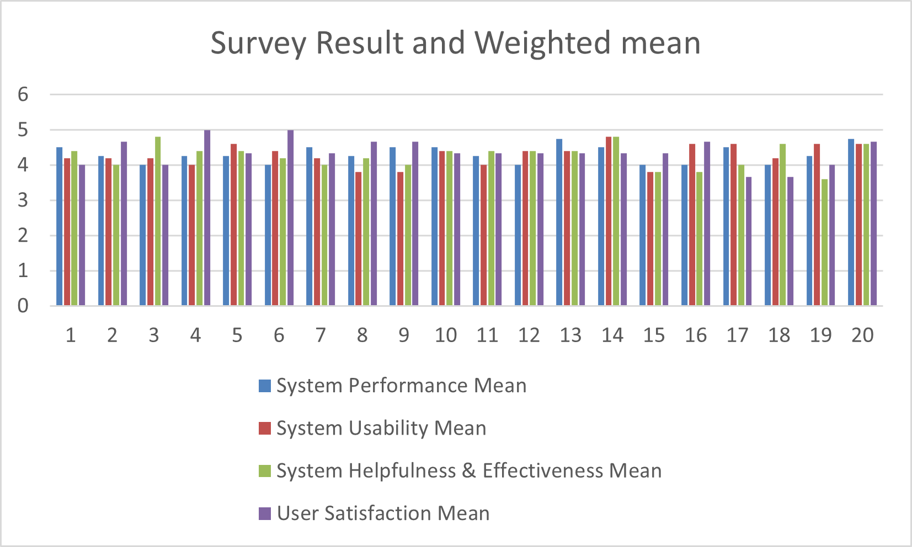
Figure 1: Clustered column for weighted Mean from all the respondents.
This shows a clear comparison of mean ratings per category for every respondent.

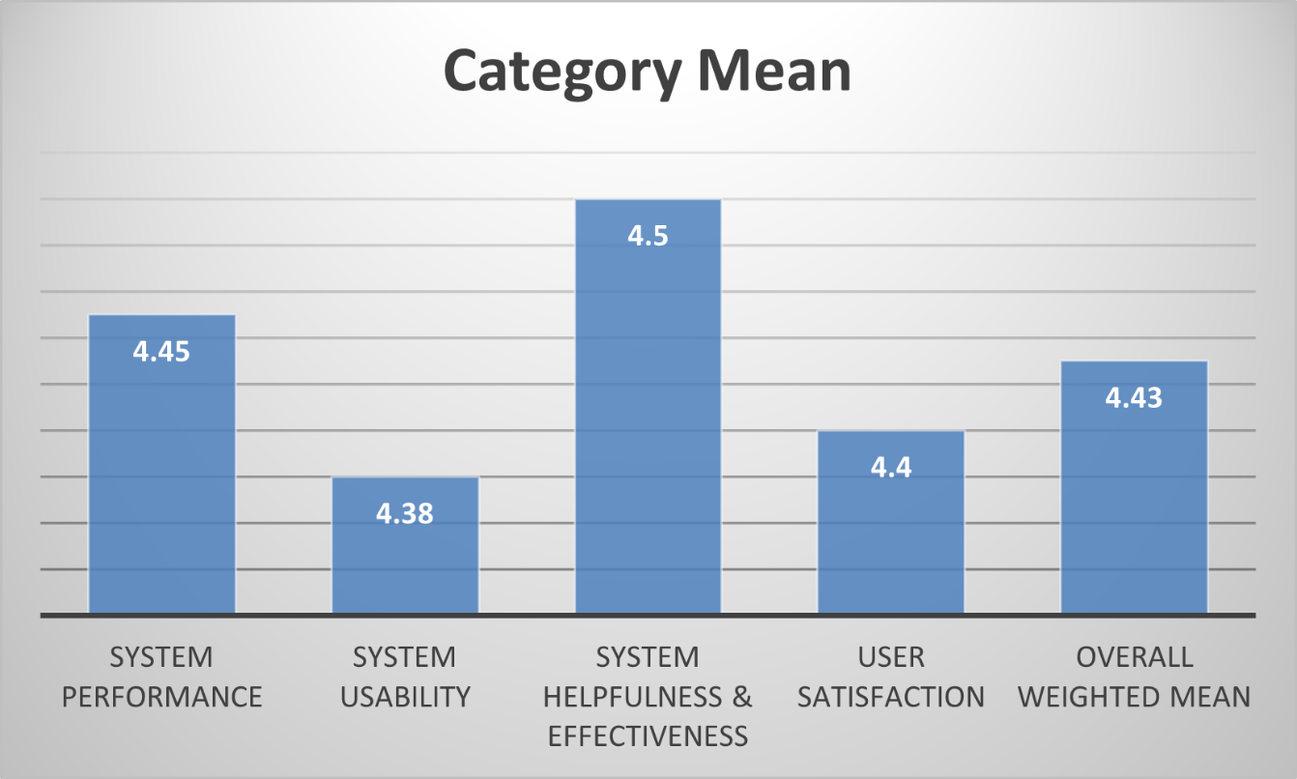
Figure 2: Bar chart showing the Mean of all the Categories.
Shows that all categories scored above 4.4, indicating strong positive evaluation

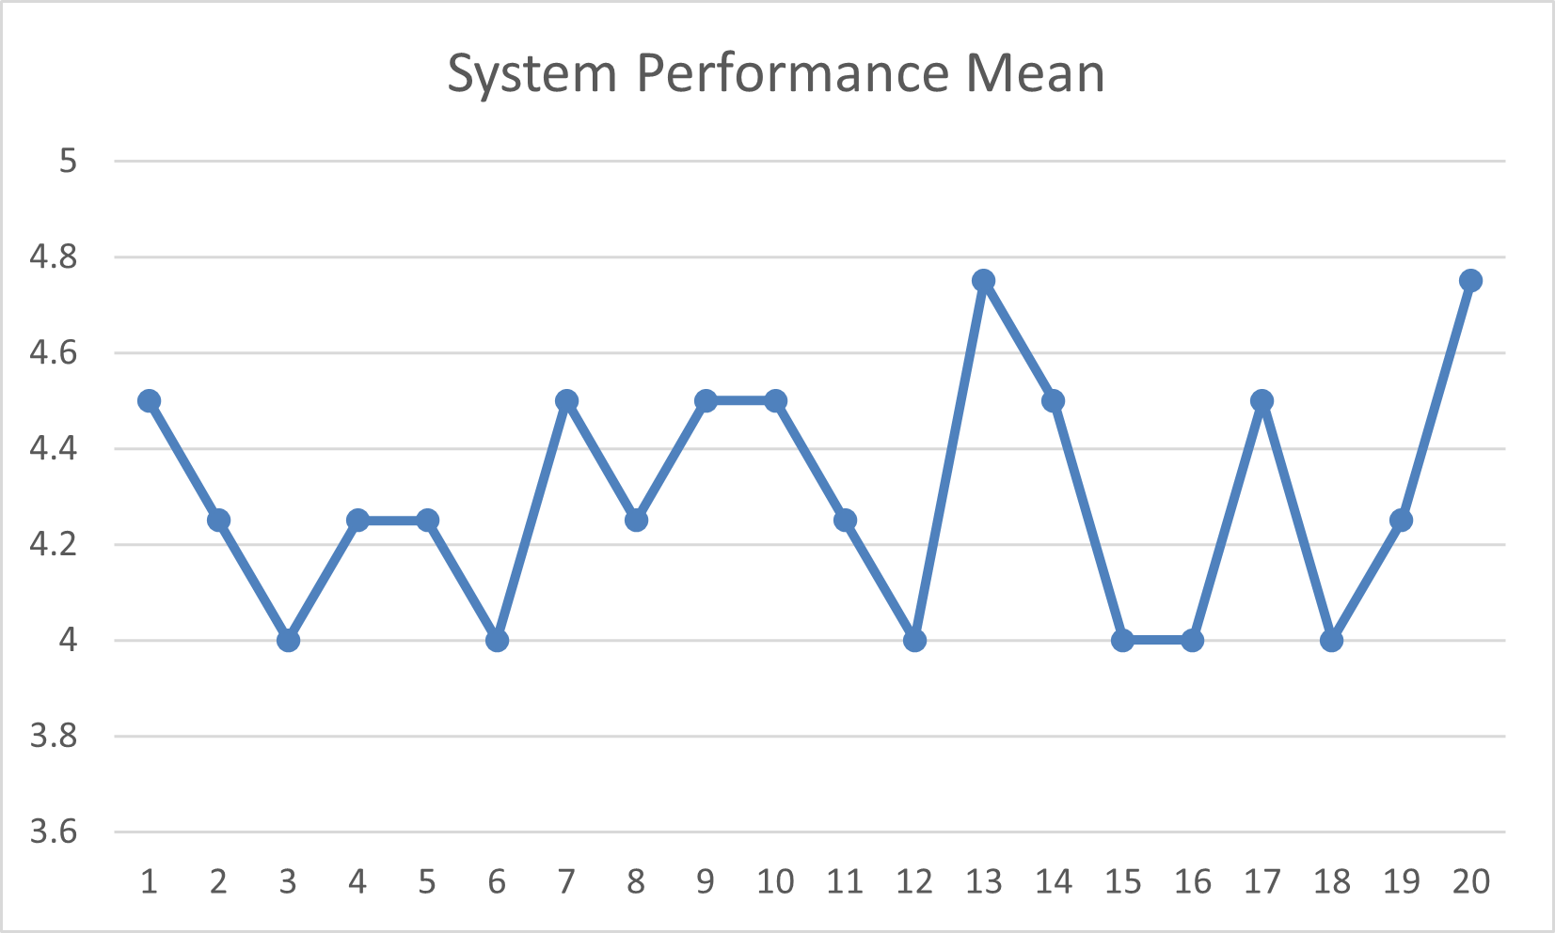
Figure 3: System Performance Test Results (Line Graph)
Shows a high response time with a score of above 4 and minimal errors based on the each of the respondent’s answer.
  - Explanation of Each Figure
- Figure 1 shows all the weighted means for all categories from each of the 20 respondents. High scores in user satisfaction and system helpfulness and most of the users are agreeing that the system was responsive, easy to use.
- Figure 2 shows a high weighted means for all of the categories, System Performance, System Usability, System Helpfulness/Effectiveness, and User Satisfaction. Overall, it shows that the users are satisfied in using the app.
- Figure 3 is showing a consistent performance with no crashes during testing.

4.5 System Performance and Testing
The CitySafe prototype was tested using simulated disaster situations to assess speed, responsiveness, and stability. During testing, the system successfully loaded maps, displayed real-time markers, and processed donations without data loss or errors.
4.5.1 Evaluation of Software Performance
Metric | Result
Average Page Load Time | 1.4 seconds
System Error Rate | 1.8%
Database Accuracy | 99%
System Uptime (During Testing) | 98%
Map and Tracking Feature Success Rate | 100%
These metrics show that CitySafe is technically stable and capable of handling real-time operations with minimal errors.

4.6 User Feedback, Testing Results, and Accuracy Rates
Respondents were asked to evaluate CitySafe based on four main areas.
4.6.1 Key Findings
A. System Performance
- Most users strongly agreed that the system loads fast and performs smoothly.
- A few noted minor slowdowns when testing with unstable internet, which is expected due to its web-based setup.
B. System Usability
- Users found the design clear, simple, and easy to navigate.
- Buttons and menus were described as intuitive and visible, making it suitable for both beginners and non-technical users.
- 92% agreed that first-time users could easily understand the system without much guidance.
C. System Helpfulness and Effectiveness
- The map and location feature was rated as the most helpful aspect, allowing users to identify safe areas and responder locations.
- The donation tracking feature was also commended for transparency and coordination potential.
D. User Satisfaction
- Respondents expressed strong satisfaction with the system’s functionality and layout.
- Most recommended that the system be further developed for real deployment by local governments.

4.7 Summary of Significant Results
The total average weighted mean of 4.43 indicates that respondents rated the CitySafe prototype as Very Satisfactory across all aspects. The results show that the system performs effectively, is easy to use, helpful in its intended purpose, and satisfactory to its users.
These findings imply that CitySafe is a promising tool for disaster management and communication, and with further development, it can serve as a reliable platform for communities during emergencies.
Evaluation Aspect | Key Result
System Performance | 4.45 mean rating in performance
System Usability | 4.38 mean rating in usability
System Helpfulness & Effectiveness | 4.5 mean rating helpfulness
User Satisfaction | 4.4 Very Satisfactory
Overall evaluation | 4.43 Very Satisfactory
Interpretation:
All key system aspects received high scores, confirming that CitySafe’s design and performance meet its development objectives. Users believe the system can assist in real disaster management operations if fully implemented.

4.8 Analysis and Interpretation
The results confirm that the CitySafe prototype successfully met its objectives during testing. Respondents found the system functional, user-friendly, and relevant to disaster response. Although the system is still under research, the feedback demonstrates a positive reception and readiness for further enhancement and deployment.
Quantitative results show that the system achieved a Very Satisfactory performance level across all categories. Qualitative feedback supports these findings, with respondents emphasizing helpfulness, clarity, and responsiveness. Minor issues—such as internet dependency and occasional loading delays—were recognized as areas for improvement in future updates.
Therefore, the data suggest that CitySafe effectively addresses the identified problem: lack of an integrated, accessible system for community-level disaster coordination.

4.9 Explanation of Trends, Patterns, or Anomalies
- Higher ratings were consistently seen in features that provided real-time and visual outputs, such as map tracking and alerts.
- Slightly lower (but still high) ratings in performance indicate that internet connectivity may affect responsiveness.
- The general pattern shows users value speed, clarity, and usefulness more than design complexity.

4.10 Identification of Strengths and Limitations
Strengths
- Real-time location and map-based features
- Organized donation and reporting modules
- User-friendly interface suitable for all age groups
- High user satisfaction and accuracy during testing
- Stable system with low error rate
Limitations
- Requires internet connection for most functions
- Prototype testing limited to small sample group
- No full mobile version yet implemented

Impact on the Information Technology Field
CitySafe contributes to the field of IT by showing how web-based technologies, database integration, and real-time mapping can be applied to community safety and disaster response. The project emphasizes how IT solutions can support transparency, faster response, and better citizen engagement during emergencies.

Contribution to Technological Advancements
The study highlights how integrating Node.js, MySQL, and Leaflet.js in a single platform can create an efficient and scalable emergency coordination tool. CitySafe demonstrates how technology can be leveraged to strengthen disaster preparedness and foster community resilience.

Code impression Management
Node.js & Express js: server.js
const express = require('express');
const session = require('express-session');
const bodyparser = require('body-parser');
const axios = require('axios');
const db = require('./db');
require('dotenv').config();

const app = express();
const PORT = process.env.PORT || 9000;
app.use(session({ secret: 'capstone', resave: false, saveUninitialized: true }));
app.set('view engine', 'ejs');
app.use(express.json());
app.use(bodyparser.urlencoded({ extended: true }));
app.use(express.static('public'));

//=====================route=====================
//visitor routes
app.get('/', (req, res) => res.redirect('/visitor'));
app.get('/visitor', (req, res) => res.render('pages/visitor', { apiKey: process.env.OWM_API_KEY }));

//authentication
app.post('/login', handleLogin);
app.post('/register', handleRegister);

//user pages
app.get('/weather', ensureUser, showWeather);
app.get('/requesthelp', ensureUser, showRequestHelp);
app.post('/postrequest', ensureUser, postUserRequest);
app.get('/assess-risk', ensureUser, showRiskForm);
app.post('/assess-risk', ensureUser, calculateRiskAssessment);

//sos / Reporting
app.get('/send-sos', ensureUser, showSOSPage);
app.post('/report', ensureUser, reportDisaster);
app.get('/nearby-stations', ensureUser, showNearbyStations);

//admin dashboard
app.get('/adminpage', ensureAdmin, showAdminDashboard);
app.get('/userslist', ensureAdmin, manageUsers);
app.post('/add', ensureAdmin, addUser);
app.post('/delete/:id', ensureAdmin, deleteUser);

//for weather
app.get('/api/weather', async (req, res) => {
const { lat, lon } = req.query;
try {
const response = await axios.get("https://api.openweathermap.org/data/2.5/weather", {
params: { lat, lon, units: "metric", appid: process.env.OWM_API_KEY },
});
res.json(response.data);
} catch {
res.status(500).json({ error: "Weather API failed" });
}
});

//verify user if admin or regular
function ensureUser(req, res, next) {
if (req.session.loggedin && req.session.role === 'user') next();
else res.redirect('/login');
}

function ensureAdmin(req, res, next) {
if (req.session.loggedin && req.session.role === 'admin') next();
else res.redirect('/login');
}

//server start
app.listen(PORT, () => console.log(`CitySafe running on port ${PORT}`));

Geolocation Code Impression
Leaflet.js
<link rel="stylesheet" href="https://unpkg.com/leaflet/dist/leaflet.css" />
<script src="https://unpkg.com/leaflet/dist/leaflet.js"></script>

<div id="map"></div>
<h6 id="address">Loading Address...</h6>
<p id="coords"></p>

<script>
const map = L.map('map').fitWorld();
L.tileLayer('https://tile.openstreetmap.org/{z}/{x}/{y}.png', {
maxZoom: 19,
attribution: '© OpenStreetMap'
}).addTo(map);

map.locate({ setView: true, maxZoom: 16, enableHighAccuracy: true });

map.on('locationfound', (e) => {
const { lat, lng } = e.latlng;
const radius = e.accuracy;

L.marker([lat, lng]).addTo(map)
.bindPopup(`You are within ${radius} meters from this point`).openPopup();
L.circle([lat, lng], radius).addTo(map);

document.getElementById("coords").textContent =
`Latitude: ${lat}, Longitude: ${lng}`;

//geocoding coordinates
fetch(`https://nominatim.openstreetmap.org/reverse?format=jsonv2&lat=${lat}&lon=${lng}`)
.then(res => res.json())
.then(data => {
const address = data.display_name;
document.getElementById("address").innerHTML = `<b>${address}</b>`;
document.getElementById("location").value = address;
})
.catch(() => {
document.getElementById("address").innerText = "Address not found.";
});
});

map.on('locationerror', (e) => alert(e.message));
</script>

System/app Screen shots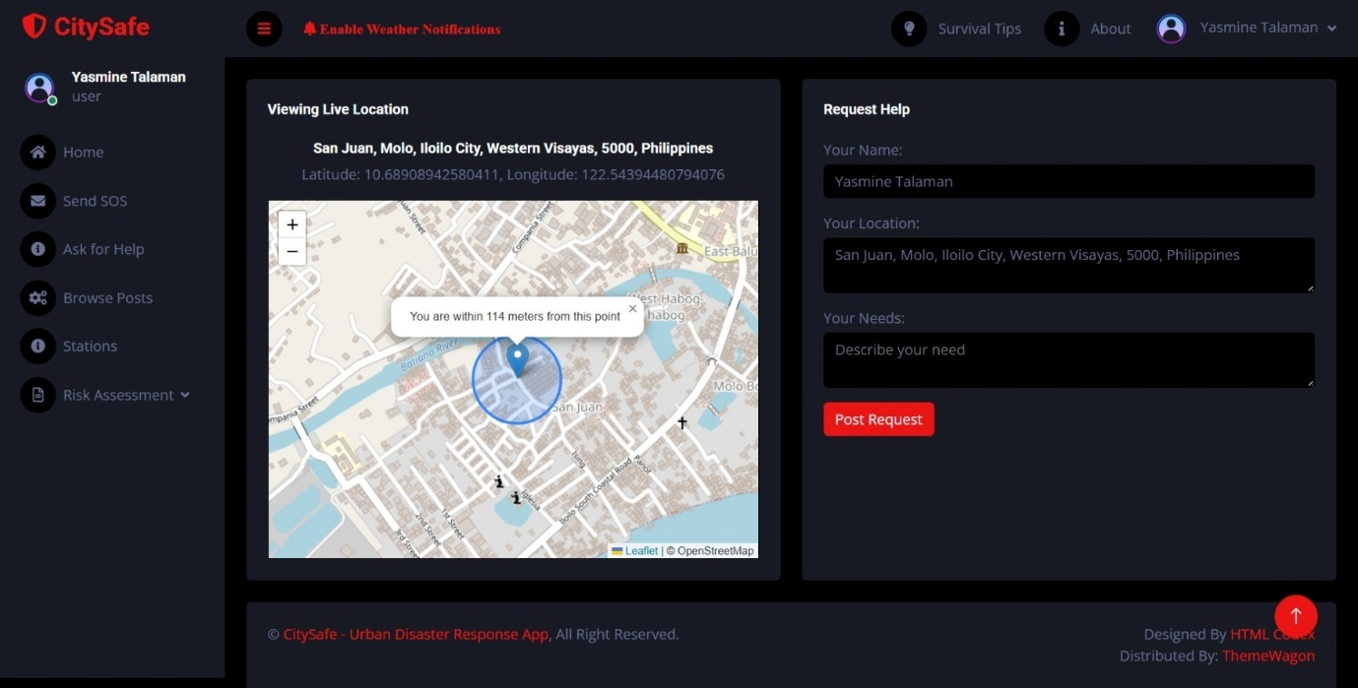
Figure A1. User Dashboard Ask for Help Section
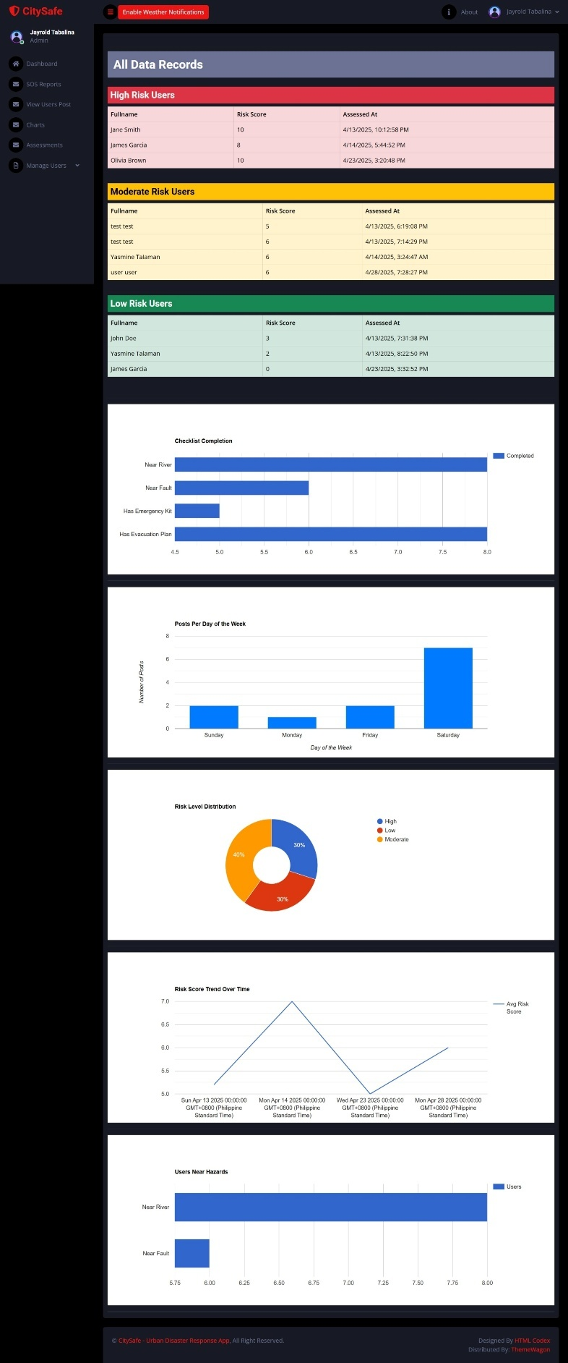
Figure A2. Admin Dashboard showing all reports/charts.

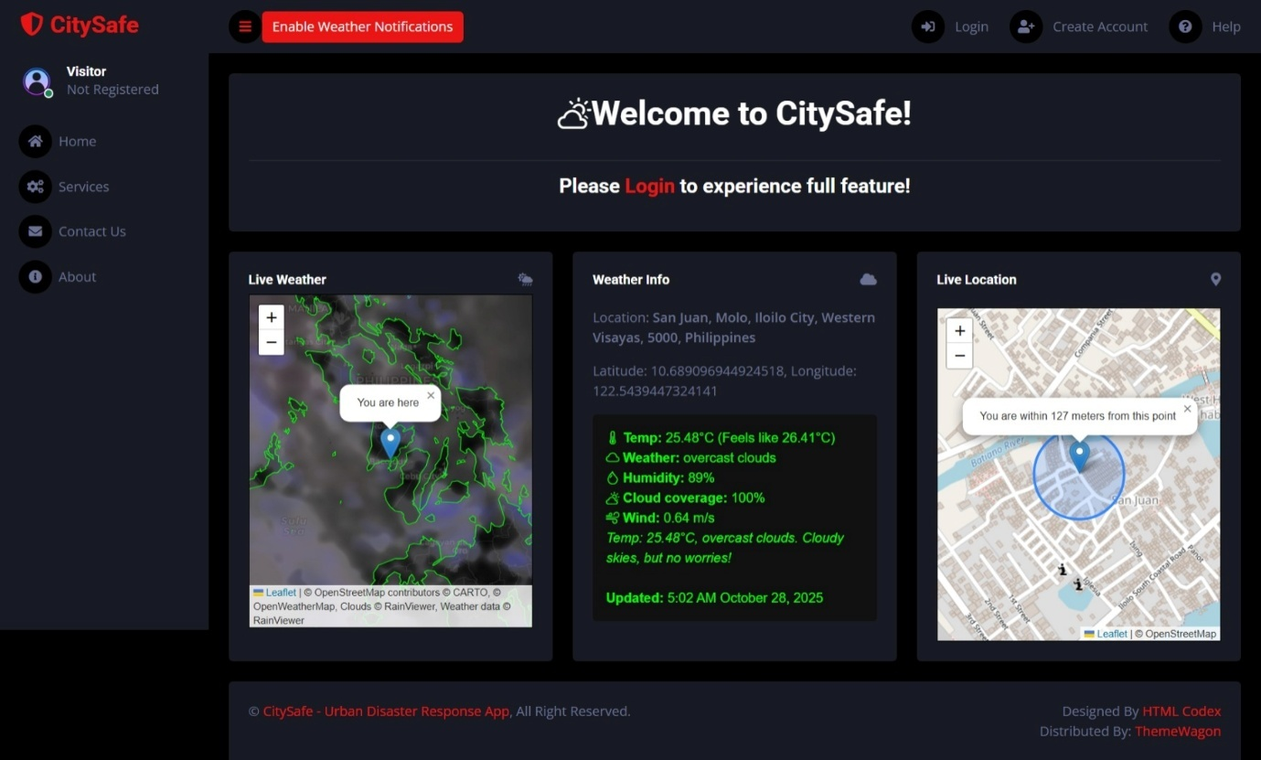Figure A3. User Interface when they are not logged in.

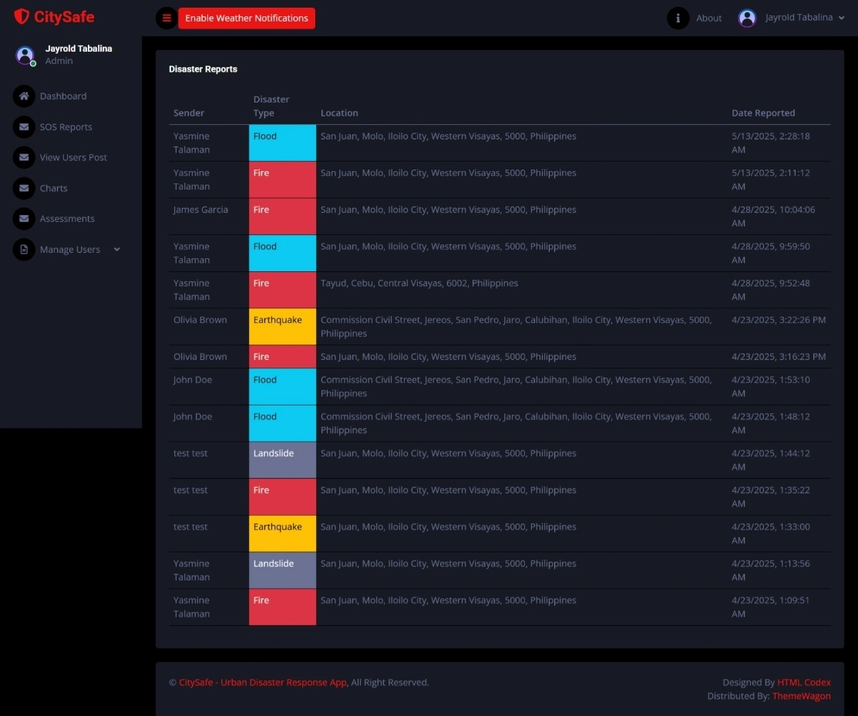
Figure A4. Admin Dashboard showing Disaster Reports.

Figure A5. Regular user interface when they are logged in.

Features of the System/App
- User Management
- Admin Management
- Weather Monitoring
- SOS and Disaster Reporting
- Help Request and Response
- Risk Assessment Module
- Location and Map Services
- Database Management (MySQL via XAMPP)
- Frontend Interface
- Separate User Pages: Every feature has its own dedicated interface.

System Repository
- GitHub repository: https://github.com/blackhatsV1/citysafe-railway
- Reverse geocoding: https://nominatim.openstreetmap.org/
- Geolocation and Mapping: https://leafletjs.com/

Project Structure
| .env
| db.js
| myapp.sql
| package-lock.json
| package.json
| server.js
+---public
| +---css
| | bootstrap.min.css
| | style.css
| |
| +---images
| | bg.jpg
| | favicon.png
| | icon.png
| | shield.png
| | user.png
| |
| +---js
| | admin.js
| | main.js
| | script.js
| |
| +---lib
| | +---chart
| | | chart.min.js
|
\---views
+---pages
| about.ejs
| aboutadmin.ejs
| aboutuser.ejs
| addusers.ejs
| adminpage.ejs
| assessment-results-admin.ejs
| contact.ejs
| disaster-reports.ejs
| edit.ejs
| editprofile.ejs
| help-user.ejs
| help.ejs
| index.ejs
| login.ejs
| nearby-stations.ejs
| reports.ejs
| requesthelp.ejs
| riskassessment.ejs
| riskassessmentresult.ejs
| services.ejs
| signup.ejs
| sos-otw.ejs
| sos.ejs
| survival-tips.ejs
| userslist.ejs
| view-users-posts.ejs
| visitor.ejs
| weather.ejs
|
\---partials
admin-navbar.ejs
admin-sidebar.ejs
footer.ejs
head.ejs
navigation-admin.ejs
navigation-visitor.ejs
navigation.ejs
selectloc-nearby-stations-.ejs
selectloc-visitor.ejs
selectloc.ejs
spinner.ejs
user-navbar.ejs
user-sidebar.ejs
visitor-navbar.ejs
visitor-sidebar.ejs

CHAPTER V

Summary, Conclusion, And Recommendation
5.1 Summary
This study aimed to design and develop CitySafe: Urban Disaster Response App, a digital platform created to improve communication, coordination, and response during disasters. The system connects citizens, donors, responders, and local officials in one integrated application. Through the use of Leaflet.js for map integration, users can locate safe zones, nearby responders, and donation areas in real time.
The development process followed the stages of planning, system design, implementation, and evaluation. The prototype was evaluated through a survey questionnaire focusing on four main aspects: system performance, usability, helpfulness, and user satisfaction.
Based on the survey results, the respondents found the system fast, functional, and user-friendly. Most agreed that CitySafe could improve disaster communication and coordination, making it a valuable tool for both citizens and emergency teams. Overall, the evaluation showed that the system met its intended goals and demonstrated strong potential for real-world application.

5.2 Conclusion
Based on the findings, the researchers conclude that the CitySafe system is an effective and reliable platform for urban disaster response and coordination. It performed well during testing, showing good system speed, functionality, and ease of use. Respondents expressed satisfaction with its features and believed it could be helpful in real disaster situations.
The results confirmed that CitySafe successfully met its objectives:
- It provides an accessible communication channel during emergencies.
- It supports real-time information sharing and coordination among users.
- It promotes community involvement by allowing easy coordinations and visualize affected citizens.
Furthermore, CitySafe demonstrates the importance of technology-driven disaster management, proving that the system can make a difference in reducing response time and improving public safety awareness.
5.3 Recommendations
Based on the project development and user feedback, the following recommendations we made for the future improvement and research:
- Offline Functionality – Add features that allow basic operations even without internet access during network outages.
- Mobile Application Version – Develop an Android or iOS version for faster access and convenience during emergencies.
- Enhanced Map and Tracking Features – Integrate real-time responder tracking and safe-zone status updates.
- Partnership with Local Government Units (LGUs) – Collaborate with official agencies for system validation, data access, and deployment in real scenarios.
- Wider User Testing – Conduct testing in various communities or cities to gather more accurate performance data and feedback.

References (APA Format)
- Domingo, S., & Manejar, A. J. (2018). Disaster Preparedness and Local Governance in the Philippines. Philippine Institute for Development Studies.

- Escolano, V. J., Caballero, A. R., Albina, E., Hernandez, A., & Juanatas, R. (2023, May). Acceptance of Mobile Application on Disaster Preparedness: Towards Decision Intelligence in Disaster Management. ResearchGate.

- Technology in Disaster Management and Recovery: Types and Impact. (2024, April 14). Tulane University.

- Merriam-Webster. (n.d.). Benefactor. In Merriam-Webster.com dictionary. Retrieved October 26, 2025, from https://www.merriam-webster.com/dictionary/benefactor

- Raba, W. J. (2025, August 12). Pacific Ring of Fire: Tracing natural disasters in Southeast Asia. Seasia: Good News from Southeast Asia. https://seasia.co/2025/08/12/pacific-ring-of-fire-tracing-natural-disasters-in-southeast-asia

